- Chemical Product and Company Identification
Product Name | Suppleyes Descaling Acid
Other Means of Identification | Descaler
Product Code | 5lt: 20110
Product Use | Dissolves scale and rust from hard surfaces.
Supplier | Suppleyes
ABN | 36 164 719 108
Mail Address | Unit 38/8 Distribution Court Arundel QLD 4214
Email | info@suppleyes.com.au
Telephone: | 07 55 949 452
Emergency Telephone: | Poisons Information Centre (National) 131126
- Hazards Identification
Statement of Hazardous Nature
This product is classified as: Xn, Harmful. N, Dangerous to the environment. C, Corrosive. Hazardous according to the criteria of SWA.
Dangerous according to Australian Dangerous Goods (ADG) Code, IATA and IMDG/IMSBC criteria.
SUSMP Classification: S6
ADG Classification: Class 8: Corrosive Substances.
UN Number: 3264, CORROSIVE LIQUID, ACIDIC, INORGANIC, N.O.S.

GHS Classification | Skin corrosion category 1

GHS Label Elements | 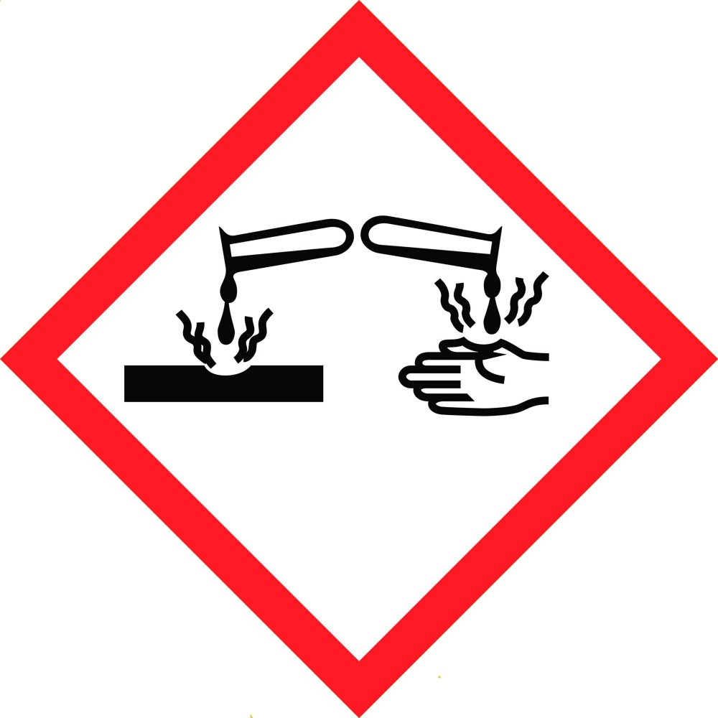
SIGNAL WORD | DANGER  Corrosive to metals - Category 1  Skin Corrosion /Irritation - Category 1B  Eye damage – Category 1  Hazardous to aquatic environment Short term/Acute - Category 3
Hazard Statement(s)

H290 | May be corrosive to metals.
H314 | Causes severe skin burns and eye damage.
H402 | Harmful to aquatic life.

Prevention(s)
P102 | Keep out of reach of children.
P262 | Do not breathe dust / fume / gas / mist / vapours / spray.
P264 | Wash hands thoroughly after handling.
P270 | Do not eat, drink or smoke when using this product.
P273 | Avoid release to the environment.
P280 | Wear protective gloves / protective clothing / eye protection / face protection.
Refer to the SDS before using this product

Response
P310 | Immediately call a POISON CENTER or doctor/physician.
P363 | Wash contaminated clothing before reuse.
P301+P330+P331 | IF SWALLOWED: Rinse mouth. Do NOT induce vomiting.
P303+P361+P353 | IF ON SKIN (or hair): Remove immediately all contaminated clothing. Rinse skin with water.
P304+P340 | IF INHALED: Remove victim to fresh air and keep at rest in a position comfortable for breathing.
P305+P351+P338 | IF IN EYES: Rinse cautiously with water for several minutes. Remove contact lenses, if present and easy to do. Continue rinsing.
P390 | Absorb spillage to prevent material damage.
P370+P378 | Not combustible. Use extinguishing media suited to burning materials. Water fog or fine spray is the preferred medium for large fires.

Storage
P405 | Store locked up

Disposal
P501 | Dispose of contents/container in accordance with local/regional/national/international regulations.

- Composition/Information on Ingredients
(Listed when present at 1% or greater, carcinogens at 0.1% or greater)

Chemical Name | CAS Registry Number | % Weight | Hazard Information
Water | >60 | 7732-18-5 | None
Phosphoric acid | 15-30 | 7664-38-2 | H290: May be corrosive to metals.  H314: Causes severe skin burns and eye damage.  TWA: 1 mg/m3  STEL: 3 mg/m3
Oxirane, 2-methyl-, polymer with oxirane, mono(2-propylheptyl) ether | <5 | 166736-08-9 | H316: Skin corrosion/irritation: Cat. 2  H319: Causes serious eye irritation
Ingredients determined to be non- hazardous | <1 | Mixture | None
The SWA TWA exposure value is the average airborne concentration of a particular substance when calculated over a normal 8 hour working day for a 5 day working week. The STEL (Short Term Exposure Limit) is an exposure value that may be equalled (but should not be exceeded) for no longer than 15 minutes and should not be repeated more than 4 times per day. There should be at least 60 minutes between successive exposures at the STEL. The term "peak "is used when the TWA limit, because of the rapid action of the substance, should never be exceeded, even briefly.
- First Aid Measures
 | General | For advice, contact a Poisons Information Centre (Australia 13 11 26) or a doctor. If swallowed, do NOT induce vomiting. Immediately give a glass of water.
 | Inhalation | If swallowed or inhaled, remove from contaminated area. Apply artificial respiration if not breathing. Do not give direct mouth-to-mouth resuscitation. To protect rescuer, use airviva, oxy-viva or one-way mask. Resuscitate in a well-ventilated area.
 | Skin: | If skin or hair contact occurs, remove contaminated clothing and flush skin and hair with running water
 | Eyes | Immediately flush the contaminated eye(s) with lukewarm, gently flowing water for at least 20-30 minutes, by the clock, while holding the eyelid(s) open. Neutral saline solution may be used as soon as it is available. DO NOT INTERRUPT FLUSHING. If necessary, keep emergency vehicle waiting (show paramedics this SDS and take their advice). Take care not to rinse contaminated water into the unaffected eye or onto face. If irritation persists, repeat flushing. Call a Poisons Information Centre or a doctor urgently. Take special care if exposed person is wearing contact lenses.
 | Ingestion: | If swallowed, do NOT induce vomiting; rinse mouth thoroughly with water and contact a Poisons Information Centre. Urgent hospital treatment is likely to be needed. Give activated charcoal if instructed.
 | Symptoms Caused by Exposure (Chronic) | No data available
 | First aid facilities | Ensure eyewash and safety shower facilities are available in workplace.
- Fire Fighting Measures
Fire and Explosion Hazards | The major hazard in fires is usually inhalation of heated and toxic or oxygen deficient (or both), fire gases. There is little risk of an explosion from this product if commercial quantities are involved in a fire.  Only small quantities of decomposition products are expected from this product at temperatures normally achieved in a fire. This will only occur after heating to dryness.  Fire decomposition products from this product are likely to be irritating if inhaled.
Extinguishing Media | Water fog or fine spray is the preferred medium for large fires. Try to contain spills, minimise spillage entering drains or water courses.
Fire Fighting | If a significant quantity of this product is involved in a fire, call the fire brigade. There is little danger of a violent reaction or explosion if significant quantities of this product are involved in a fire. Recommended personal protective equipment is liquid-tight chemical protective clothing and breathing apparatus.
Flash Point | None
Upper Flammability Limit: | Does not burn
Lower Flammability Limit: | Does not burn
Auto ignition temperature | Not applicable - Does not burn
Flammability Class: | Does not burn

- Accidental Release Measures
Personal Precautions | Wear protective eyewear, chemical resistant boots, impervious overalls and gloves.
Environmental Precautions | Seek disposal options by a licensed waste contractor
Minor Spills | Clean up all spills immediately.  Avoid breathing vapours and contact with skin and eyes.  Control personal contact with the substance, by using protective equipment.  Contain and absorb spill with sand, earth, inert material or vermiculite.  Wipe up.  Place in a suitable, labeled container for waste disposal.
Major Spills | Clear area of personnel and move upwind.  Alert Fire Brigade and tell them location and nature of hazard.  Wear full body protective clothing with breathing apparatus.  Prevent, by any means available, spillage from entering drains or water course.  Stop leak if safe to do so.  Contain spill with sand, earth or vermiculite.  Collect recoverable product into labeled containers for recycling.
- Precautions for handling and storage
Precautions for Safe Handling | Keep exposure to this product to a minimum, and minimise the quantities kept in work areas. Check Section 8 of this SDS for details of personal protective measures, and make sure that those measures are followed. The measures detailed below under "Storage" should be followed during handling in order to minimise risks to persons using the product in the workplace. Also, avoid contact or contamination of product with incompatible materials listed in Section 10.
Conditions for Safe Storage | This product is a Scheduled Poison. Observe all relevant regulations regarding sale, transport and storage of this schedule of poison. Store in a cool, well ventilated area. Check containers periodically for corrosion and leaks. Containers should be kept closed in order to minimise contamination. Make sure that the product does not come into contact with substances listed under "Incompatibilities" in Section 10. If you keep more than 10000kg or L of Dangerous Goods of Packaging Group III, you may be required to license the premises or notify your Dangerous Goods authority. If you have any doubts, we suggest you contact your Dangerous Goods authority in order to clarify your obligations. Check packaging - there may be further storage instructions on the label.

- Exposure controls /personal protection
The following Australian Standards will provide general advice regarding safety clothing and equipment:
Respiratory equipment: AS/NZS 1715, Protective Gloves: AS 2161, Occupational Protective Clothing: AS/NZS 4501 set 2008, Industrial Eye Protection: AS1336 and AS/NZS 1337, Occupational Protective Footwear: AS/NZS2210.

SWA Exposure Limits | TWA (mg/m3) | STEL (mg/m3)
Phosphoric Acid | 1 | 3

No special equipment is usually needed when occasionally handling small quantities. The following instructions are for bulk handling or where regular exposure in an occupational setting occurs without proper containment systems. Ventilation: This product should only be used in a well ventilated area. If natural ventilation is inadequate, use of a fan is suggested.

Engineering Controls

Individual Protection | Avoid generation and inhalation of mists and aerosols
Eyes/Face protection | Your eyes must be completely protected from this product by splash resistant goggles with face shield. All surrounding skin areas must be covered. Emergency eye wash facilities must also be available in an area close to where this product is being used.
Skin protection | Because of the dangerous nature of this product, make sure that all skin areas are completely covered by impermeable gloves, overalls, hair covering, apron and face shield. See below for suitable material types
Protective materials | We suggest that protective clothing be made from the following materials: rubber, PVC and Viton.
Respiratory | Usually, no respirator is necessary when using this product. However, if you have any doubts consult the Australian Standard mentioned above. Otherwise, not normally necessary. Safety deluge showers should, if practical, be provided near to where this product is being handled commercially.
- Physical and chemical properties
Appearance | Clear, colourless liquid.
Odour: | Faint odour
pH | 0.5-1.5 (as supplied)
Vapour pressure: | No data.
Vapour Density: | No data.
Boiling Point: | Approximately 100°C
Boiling range | No data.
Melting point | No data.
Solubility in water | Miscible in all proportions
Specific Gravity: | 1.2 @ 25 C
Flash point | Not flammable
Solubility limits | Completly soluble in water
Per Cent Volatile | 20 % v/v
- Stability and Reactivity
Chemical Stability | The product is stable under normal conditions
Conditions to Avoid | Most strong acids react with inorganic and organic bases such as amines to form salts. They also react with many metals liberating hydrogen gas. These reactions are often rapid and sometimes liberate much heat. They can also decompose many organic materials such as esters, in a reaction called hydrolysis.
Conditions to Avoid | Keep containers tightly closed. Containers should be kept dry.
Incompatible Materials | amines, zinc, tin, aluminium and their alloys, other substances reactive with strongly acidic liquids.
Hazardous Decomposition Products | Only small quantities of decomposition products are expected from this product at temperatures normally achieved in a fire. This will only occur after heating to dryness. Combustion forms carbon dioxide, and if incomplete, carbon monoxide and possibly smoke. Water is also formed. May form oxides of sulfur (sulfur dioxide is a respiratory hazard) and other sulfur compounds. Most will have a foul odour. May form oxides of phosphorus and other phosphorus compounds. Carbon monoxide poisoning produces headache, weakness, nausea, dizziness, confusion, dimness of vision, disturbance of judgment, and unconsciousness followed by coma and death.
Polymerisation: | This product will not undergo polymerisation reactions.
- Toxicological information
Local Effects:
Target Organs: There is no data to hand indicating any particular target organs.
Classification of Hazardous Ingredients

Ingredient | Risk Phrases
Phosphoric Acid  Skin corrosion - category 1B | Conc>=25%: C; R34

Potential Health Effects

Inhalation:
Short Term Exposure: Available data indicates that this product is not harmful. However product may be mildly irritating, although unlikely to cause anything more than mild transient discomfort. If liquid enters nasal passages, it will cause pain and burn nasal membranes. Patients with inhalation burns may develop acute pulmonary oedema. Long Term Exposure: No data for health effects associated with long term inhalation.
Skin Contact:
Short Term Exposure: This product is corrosive to the skin. Capable of causing moderate to severe burns with ulceration. Can penetrate to deeper layers of skin, resulting in third degree burns. Corrosion will continue until product is removed or neutralised. Severity depends on concentration and duration of exposure. Burns may not be immediately painful; the onset of pain may be minutes to hours.
Long Term Exposure: No data for health effects associated with long term skin exposure.
Eye Contact:
Short Term Exposure: This product is corrosive to eyes. It will cause severe pain, and corrosion of the eye and surrounding facial tissues. Unless exposure is quickly treated, permanent blindness and facial scarring is likely. Long Term Exposure: No data for health effects associated with long term eye exposure.
Ingestion:
Short Term Exposure: Significant oral exposure is considered to be unlikely. Available data shows that this product is harmful, but symptoms are not available. However, this product is corrosive to the gastrointestinal tract. Capable of causing moderate to severe burns with ulceration. Can penetrate to deeper layers of skin, resulting in third degree burns. Corrosion will continue until product is removed or neutralised. Severity depends on concentration and duration of exposure.
Long Term Exposure: No data for health effects associated with long term ingestion.
Carcinogen Status:
SWA: No significant ingredient is classified as carcinogenic by SWA. NTP: No significant ingredient is classified as carcinogenic by NTP.
IARC: No significant ingredient is classified as carcinogenic by IARC.

- Ecological information
This product is harmful to aquatic organisms. This product will not accumulate in the soil or water or cause long term problems. However, until diluted or neutralised it will kill all aquatic organisms it contacts due to extreme pH.
- Disposal considerations
Disposal | Containers should be emptied as completely as practical before disposal. If possible, recycle product and containers either in-house or send to recycle company. If this is not practical, send to a commercial waste disposal site.
- Transport Information
Dangerous according to Australian Dangerous Goods (ADG) Code, IATA and IMDG/IMSBC criteria.

UN Number | 3264, CORROSIVE LIQUID, ACIDIC, INORGANIC, N.O.S.
Hazchem Code | 2X
Limited quantities | ADG 7 specifies a Limited Quantity value of 5 L for this class of product.
DG Class | Class 8: Corrosive Substances.
SUBSIDARY RISK | none allocated
Packaging Group | III
Packaging Instructions | P001, IBC03, LP01
Class 8 Corrosive Substances shall not be loaded in the same vehicle or packed in the same freight container with Classes 1 (Explosives), 4.3 (Dangerous When Wet Substances), 5.1 (Oxidising Agents), 5.2 (Organic Peroxides), 6 (Toxic Substances where the Toxic Substances are cyanides and the Corrosives are acids), 7 (Radioactive Substances), Foodstuffs and foodstuff empties. They may however be loaded in the same vehicle or packed in the same freight container with Classes 2.1 (Flammable Gases), 2.2 (Non-Flammable, Non-Toxic Gases), 2.3 (Poisonous Gases), 3 (Flammable liquids), 4.1 (Flammable Solids), 4.2 (Spontaneously Combustible Substances), 6 (Toxic Substances except where the Toxic Substances are cyanides and the Corrosives are acids) and 9 (Miscellaneous Dangerous Goods).
- Regulatory Information
Packaging and Labelling | AICS: All of the significant ingredients in this formulation are compliant with NICNAS regulations.  The following ingredient: Phosphoric acid is mentioned in the SUSMP.
- Other information

Abbreviations
AICS | Australian Inventory of Chemical Substances
CAS Number | Unique Chemical Abstracts Service Registry Number
EC50 | Ecotoxic Concentration 50% — concentration in water which is fatal to 50% of a test population (e.g. daphnia, fish species)
ES | Exposure Standard - The airborne concentration of a biological or chemical agent to which a worker may be exposed in a work day
GHS | Globally Harmonised System of Classification and Labelling of Chemicals
HAZCHEM Code | Emergency action code of numbers and letters that provide information to emergency services, especially fire fighters
IARC | International Agency for Research on Cancer
LEL | Lower Explosive Limit
LD50 | Lethal Dose 50% — dose which is fatal to 50% of a test population (usually rats).
LC50 | Lethal Concentration 50% — concentration in air which is fatal to 50% of a test population (usually rats)
NICNAS | National Industrial Chemicals Notification and Assessment Scheme
Peak Limitation | Peak Exposure Value: The maximum airborne concentration of a biological or chemical agent to which a worker may be exposed at any time.
SDS | Safety Data Sheet
STEL | Short Term Exposure Limit - The maximum airborne concentration of a chemical or biological agent to which a worker may be exposed in any 15 minute period, provided the TWA is not exceeded
TWA | Time Weighted Average — generally referred to ES averaged over typical work day (usually 8 hours)
UEL | Upper Explosive Limit
UN Number | United Nations Number

References
Data | Unless otherwise stated comes from IUCLID datasheet for the specific chemical.
NOHSC: 1003 | National Occupational Health and Safety Commission 1995, Exposure Standards for Adopted National Exposure Standards for Atmospheric Contaminants in the Occupational Environment [NOHSC:1003(199511

Prepared By | Jon Sprinkhuizen
Date of Issue | 1st of February 2021
Changes Made | Update SDS to GHS format
References | Australian Dangerous Goods Code Preparation of Safety Data Sheets for Hazardous Chemicals Code of Practice 2011. Standard for the Uniform Scheduling of Medicines & Poisons (SUSMP) Guidance
Contact Person/Point | Australia 24 HOUR EMERGENCY CONTACT Poisons Information Centre 13 11 26
Legal Disclaimer | The above information is believed to be correct with respect to the formula used to manufacture the product in the country of origin. As data, standards, and regulations change, and conditions of use and handling are beyond our control, NO WARRANTY, EXPRESS OR IMPLIED, IS MADE AS TO THE COMPLETENESS OR CONTINUING ACCURACY OF THIS INFORMATION.

End of SDS

